Place these events in chronological order:
- Beginning of the Siege of Leningrad
- Allies take Sicily
- Beginning of the Battle of Britain
- Battle of El Alamein
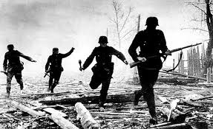
- Hitler attacks Denmark and Norway
- Lend-Lease Act
- VE Day
- Hitler invades Poland
- Hitler attacks the Soviet Union
- Japan attacks Pearl Harbor
- Paris falls to the Nazis
- Battle of the Bulge
- D-Day

