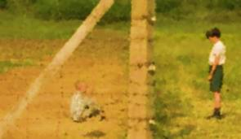
The Boy in the Striped Pajamas Name_________________________________
Use back of the page if you need more space Period______
- What do “innocent” and “naïve” mean when used to describe children?

- How does the opening scene of Bruno and his friends represent their innocence?

- Can adults be naïve? In what ways can they be naïve? What adults in the film seemed naïve?

- Give an example of a time when you were young and saw the world from a more innocent perspective.

- Does Bruno and Gretel’s tutor take advantage of the children’s innocence in what he teaches them? How? What were those ideas?

- What events/experiences lead Bruno to gradually give up some of his innocence and see things differently?

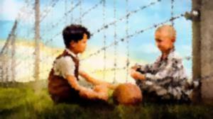
- Why was it so hard for Bruno to believe that his father could be involved in harmful acts?

- Neither Bruno nor Shmuel really know what’s going on in the concentration camp. Why is that, and what allows them to keep their innocence?

- Why do you think the movie ended the way it did?

