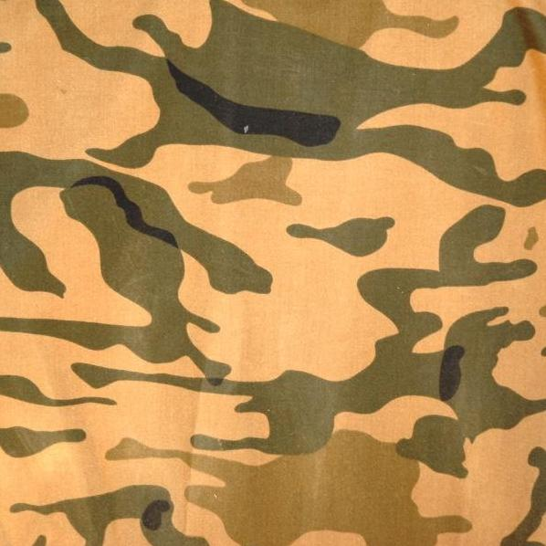
Vietnam Reading guide Name______________________
section 3 Essential question: How did the Vietnam war affect the political and social climate in the United states?
*1968 presidential election: positions on Vietnam
as you read section 3 (476-481), fill in the chart below to identify each candidate’s position on the Vietnam war.
Hubert H. Humphrey (democrat) Richard m. Nixon (republican)
__________________________________________ __________________________________________
__________________________________________ __________________________________________
__________________________________________ __________________________________________
*answer the following questions to check your understanding of section 3.
1. determining cause and effect—how did deferments affect the composition (who is serving) of the military?

2. Speculating—why do you think president Johnson did not run for reelection?

section 4 essential question: how did president Nixon remove the United states from the Vietnam war?
*as you read section 4 (484-490), complete the chart below to list major events that led to the end of u.S. involvement in Vietnam.
1. Dec. 1970 2. Fall 1972 3. Dec. 1972 4. Jan. 1973

*read the following selection, and then answer the question at the end.
Shortly after taking office, President Nixon began taking steps to end U.S. involvement in Vietnam. Nixon appointed Henry Kissinger as his national security adviser. Kissinger worked to improve relations with the Soviet Union and China. These two countries supplied aid to North Vietnam. Kissinger hoped they would cut back on their aid and help end the war.
Nixon came up with a “peace with honor” strategy. It had three parts. First, draft reforms did away with deferments and chose draftees by lottery. The reforms also limited the draft to 19-year-olds. Second, Nixon began to pull U.S. troops from Vietnam. This plan was called Vietnamization. It made the South Vietnamese do more of the fighting. Third, Nixon ordered the bombing of enemy supply routes in Cambodia and Laos. Nixon kept the bombing of Cambodia secret.
Question: name the two countries that supplied aid to the north Vietnamese.

1._________________________________________ 2.______________________________________

*read the following selection, and then complete the statement at the end.
American troops were not given a hero’s welcome when they returned home. The public just wanted to forget the war. Some American soldiers were MIA, or missing in action. They did not return from the war. Their families asked the government to pressure the Vietnamese for information about the soldiers. Vietnam allowed American groups to search the country, but the MIAs were not found.

Statement: MIAs are soldiers who are ________________________________________________.

*answer these questions to check your understanding of section 4.
1. Analyzing—what was the goal of Vietnamization?

2. Determining cause and effect—name two effects of Nixon’s invasion of Cambodia.

