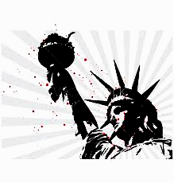
Civil Rights Quiz
- What did the Brown v Board of Education do for African Americans?

- Why did Orval Faubus send in the National Guard?

- Who was Ernest Green?

- What event led to the Montgomery Bus boycott?

- Name one thing the Civil Rights Act of 1964 did?

- What did the march in Selma, AL, lead to?

- Why were the beliefs of the Black Power Movement different from Dr. King’s?

- Which President signed both major pieces of legislation during the Civil Rights Movement?

- Explain why Civil Rights leaders also needed the Voting Rights Act of 1965 to achieve equality.

- What did Civil Rights leaders realize they needed for non-violent resistance to be truly effective?

