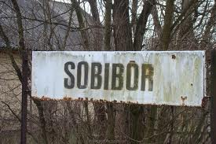
Escape From Sobibor: Quiz Name_____________________
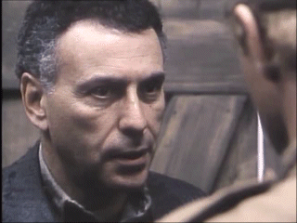
Period_____

_____1. Sobibor was located in what country?
- Germany
- Yugoslavia
- Hungary
- Poland
_____2. Some of the deportees were advised at the train station to
- Claim they had dysentery.
- Say they had a “trade.”
- “Run like the wind, and don’t look back.”
- Never speak German.
_____3. The Jews working at the train station were warned to
- Make sure the deportees stayed calm.
- Make the area look presentable.
- Always salute a superior officer.
- Never bring a baby into the camp.
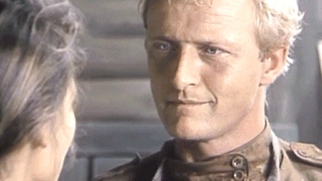
_____4. A woman deportee refused to give up her duffle bag because it contained
- A baby
- Rabbits
- Her sewing equipment
- Her goldsmithing tools
_____5. Luka went from working as a seamstress to taking care of the
- Infants
- Cattle
- Rabbits
- Nazis
_____6. How did discover that his wife and child were dead?
- He saw them in front of a firing squad.
- He found his daughter’s clothes while sorting.
- The camp commandant told him.
- Sasha had them murdered.
_____7. One of the Nazis said, “These Dutch will behave themselves.” What was the biggest difference between the Dutch and the usual deportees?
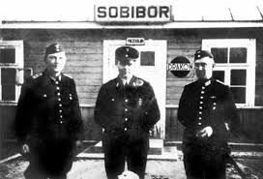
- Most of them were from a higher socio-economic group.
- The Dutch were more frightened of the Nazis.
- The leader of the Dutch warned them to be obedient.
- The Dutch Jews weren’t Orthodox.
_____8. Thirteen men were forced to
- Pick a “death-partner.”
- Work without rations for 50 days.
- Place a gold coin on each Nazi’s uniform.
- Dig a tunnel at least 50 yards long.

_____9. Sasha and his men were
- Warned not to go with the women and children to the showers.
- Captured Russian soldiers who were all Jewish.
- Able to escape the showers because of their ability as chefs.
- Ukrainian by birth, but sided with the Nazis once the war began.
_____10. The escape plan was for freeing which of the prisoners?
- All who could get through the tunnel in 10 hours.
- All the Kapos and those healthy enough to fight.
- Only the shoemakers and goldsmiths.
- All 600 of the prisoners.
_____11. Part of the escape plan was to use what traits of the Germans against them?
- Punctuality and greed.
- Sloth and bad hygiene.
- Athleticism and pride.
- Claustrophobia and guilt.
_____12. What does Luka give to Sasha?
- A good luck kiss.
- A good luck shirt.
- A good luck rabbit’s foot.
- A good luck whistle.

