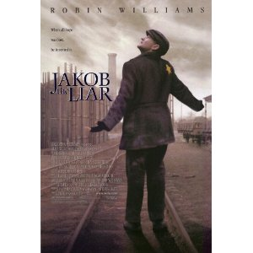
“Finish That Quote” Name___________________
Period_____
- Jakob: Hitler goes to a fortune teller and asks, “When will I die?” And the fortune teller replies, “On a Jewish holiday.” Hitler then asks, “How do you know that?” And she replies,
_______________________________________.
- Lina: What happened to your wife?
Jakob: They shot her. Under a tree. I don’t know what

kind of a tree it was. I didn’t ___________________.

3. Jakob: Oh, God of the Jews! Why didn’t you make your people a race of __________?
4. Jakob: I’ll ___________that bridge when I get to it.
5. Jakob: Here’s a book about Africa. You read this, you’ll forget________________________.
6. Mischa: If you had one and didn’t want anyone to know….the best way would be to say you had one…because no one owning a radio would be stupid enough to admit it. They’d leave you alone, which means…What does it mean, Jakob?
Jakob: I don’t know.
Mischa: It means you’ve got a radio.
Jakob: I don’t have a radio.
Mischa: ____________________.
7. Jakob: Hunger for __________may be worse than hunger for food.
8. Jakob: I believe we are the chosen people…but I wish the Almighty had __________________
____________________
9. Mischa: So, now that you’ve shared a toilet seat with the master race, maybe you’ll be good enough
to ________________________________________.
10. Jakob: But maybe it wasn’t like that at all. Because as you know, as Frankfurter says, “until the
last line has been spoken, _________________________________________.”

