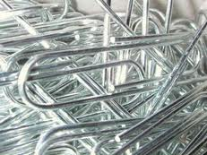
- In what state is Whitwell located?
- How many paper clips did the students eventually collect?
- How did the school decide to display the paper clips?
- What was the total number of paper clips that went into the display?
- What was in the suitcase?
- In what month did Kristallnacht occur?
- What did the school do on the anniversary of Kristallnacht?
- What images were painted on the sidewalk around the display?
- Reflective Writing:
  - Compare and contrast Whitwell with the RayPec community.
  - Why do you think there was such great interest in the paper clip project?

