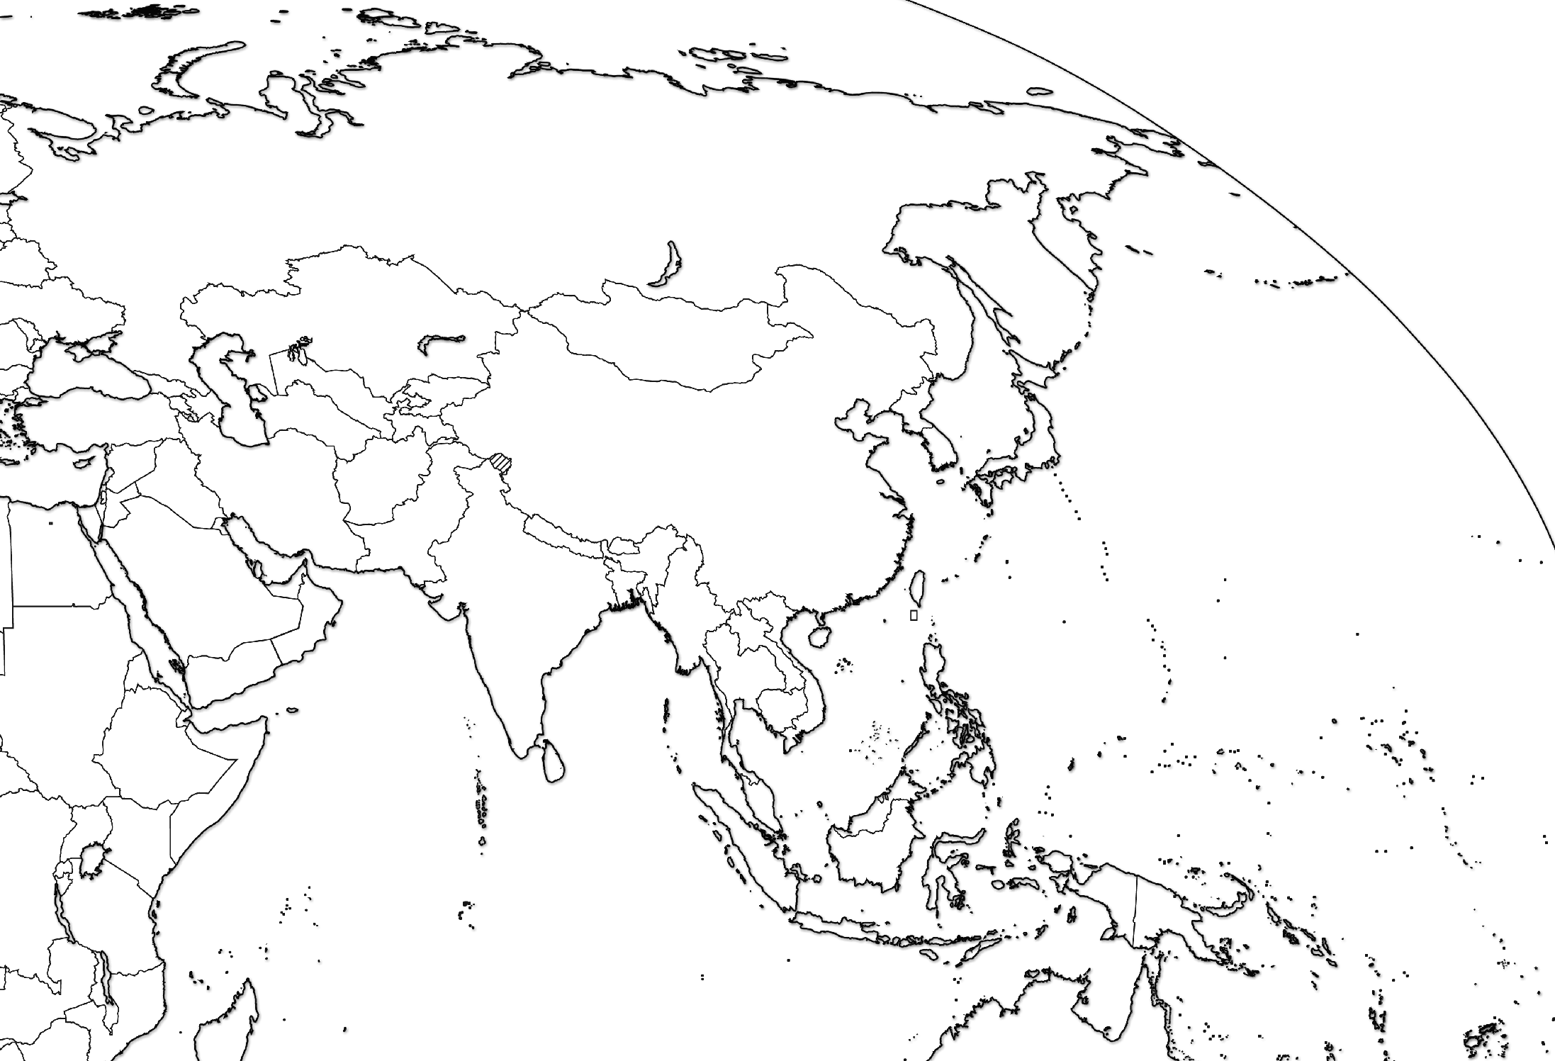
Eurasian Map: Label the following nations,
cities, and bodies of water.

Nations
Syria, Turkey, Lebanon, Israel, Egypt,
Saudi Arabia, Iraq, Iran, Afghanistan,
Pakistan, India, Oman, Yemen, Qatar, Kuwait,
United Arab Emirates, Turkmenistan, Armenia,
Azerbaijan, Georgia, Sudan, Kenya, Tanzania
Cities
Baghdad, Tehran, Riyadh, Istanbul, Beirut,
Jerusalem, Cairo, New Delhi, Islamabad, Masqat,
Sanaa, Khartoum
Bodies of Water
Indian Ocean, Persian Gulf, Red Sea, Arabian Sea,
Gulf of Oman, Mediterranean Sea, Black Sea,
Caspian Sea, Aral Sea

