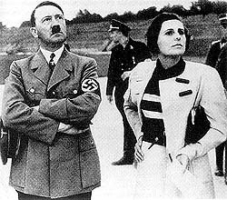
Holocaust Studies: Triumph of the Will Name___________________
Period_____

Background
- The film was made to show a microcosm of 1934 Germany. It does not document so much of what Germany was, but of the Germany Hitler willed it to become. The film was made 18 months after the 1933 election that created the National Government. By this time, the offices of Chancellor and President were controlled by Hitler.
- Since this was a time before television and radio were in wide use, most Germans had never seen or heard Hitler, even though he was the new leader of the country. The film was a means of introducing Hitler and the Third Reich to Germans. The film played to sold out movie theaters across Germany. It also served as a warning to foreign (especially European) countries that Germany had awakened and they could not be pushed around anymore.
- Leni Riefenstahl co-wrote and directed Triumph of the Will. She was born Berta Helene Amalie Riefenstahl on August 22, 1902, in Berlin. As a successful dancer, a career in film acting gave way when she attracted the attention of film director Arnold Fanck. With Fanck as a guide, Riefenstahl began directing film. After earning acclaims and awards for her artistic work, she was hired by Adolf Hitler to make Triumph of the Will. For her work, Riefenstahl was awarded a Cultural Achievement award from the Third Reich, as well as a gold medal at the 1937 World Exhibition in Paris. Although protesting otherwise, Riefenstahl is considered an instrumental part of the Third Reich’s propaganda powerhouse. After the war ended, Riefenstahl refused to admit that she had any part in Nazi atrocities, and was not associated with the party whatsoever. Shunned, she did not make a movie for the rest of her life. She died in September 2003. She was 101.
Questions
- What was the theme of this film?

- What was Riefenstahl trying to tell the viewer? Did she succeed?

- What did you like best about the film?

- What did you like least about the film?

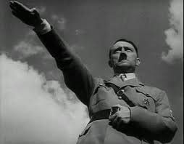
- Was there something about the film you didn’t understand? Be specific.

- Would the film have had the same effect on an audience without the music? Explain.

- How would Hitler have used Triumph of the Will to motivate Germans?

- How would Hitler have used the film to discourage any force being used against Germany?

- How would the popularity of the film affect Germans?

- Final thoughts…

