Westward Expansion Graphic Organizer

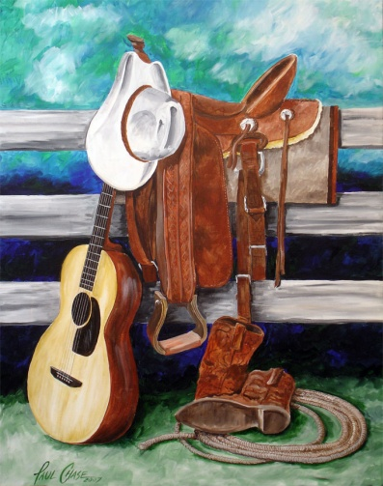
The purpose of this project is for you to demonstrate your understanding of the three cultures that existed in the westward portion of the United States during the late 1800’s. You will need to create some type of graphic organizer that compares and contrasts the cultures of the Native Americans, Farmers, and the Cowboys. You should describe each category and how it applies to the 3 cultures discussed. You should also explain similarities and differences between the cultures for each category and how they might have interacted. The following six categories should be compared:
1. Mode of survival 1 2 3 4
2. Daily Life 1 2 3 4
3. Use of the land/use of fences 1 2 3 4
4. Housing 1 2 3 4
5. View about railroads and technology 1 2 3 4
6. Obstacles in the West 1 2 3 4

Your project will be graded using the following scoring guide:

*Each of the 6 categories is graded
On a 4 point scale.

Excellent (4) Good (3) Fair (2) Poor (1) N/A
^ Explains each group w/ ^ Explains each ^Explains each ^Each group is ^No group
Similarities and differences group w/Similarities group not explained mentioned
And cultural interactions and differences

*Graphic organizer has pictures, 4 3 2 0 x1 ____
drawings, and other relevant illustrations
that supports the information given.

*Graphic organizer is neat and presentable 4 3 2 0 x 1 ____

Total ______/32
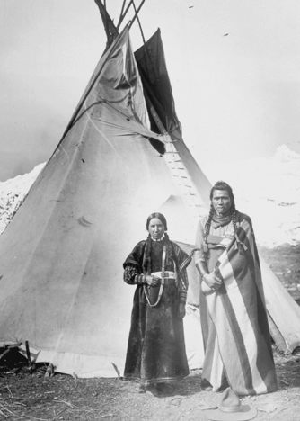
Comments:

