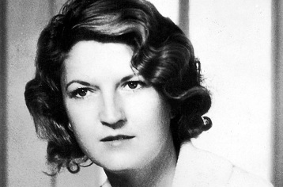
Anticipation Guide: Rebel Without a Pause
(Zelda Fitzgerald)

- Briefly compare the characteristics of Victorian women to modern women.

- What was a bootlegger?

- What was a speakeasy?

Post-Reading Questions

- What were Zelda’s ideas about how flappers should live? (please cite the paragraph number)

- Identify two things that Zelda did that showed she rebelled against tradition. (please cite the paragraph number)

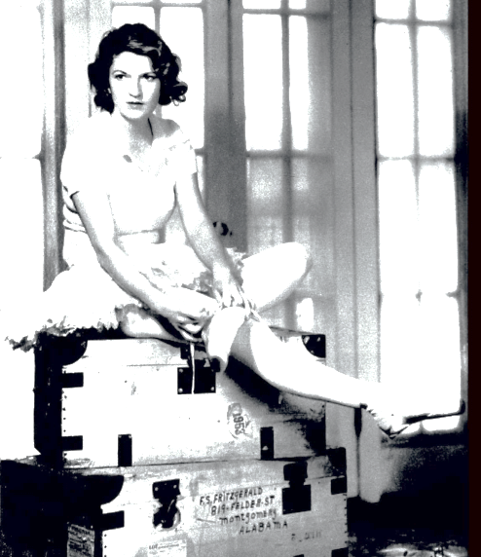
- Scott and Zelda, like some other people, went to illegal nightclubs. Was it wrong for them to have done that? Why or why not? Please answer on the back of this page.

